**DSA0606 -DATA HANDLING AND DATA VISUALIZATION FOR CLUSTERING ALGORITHMS**

**Gundala Srija (192124121)**

**Case study - 1**

Consider that you are with the following data table and its associated graph: Stacked Bar Chart, Line Plot, Scatter Plot and Mosaic Plot, Histogram.

Stacked Bar

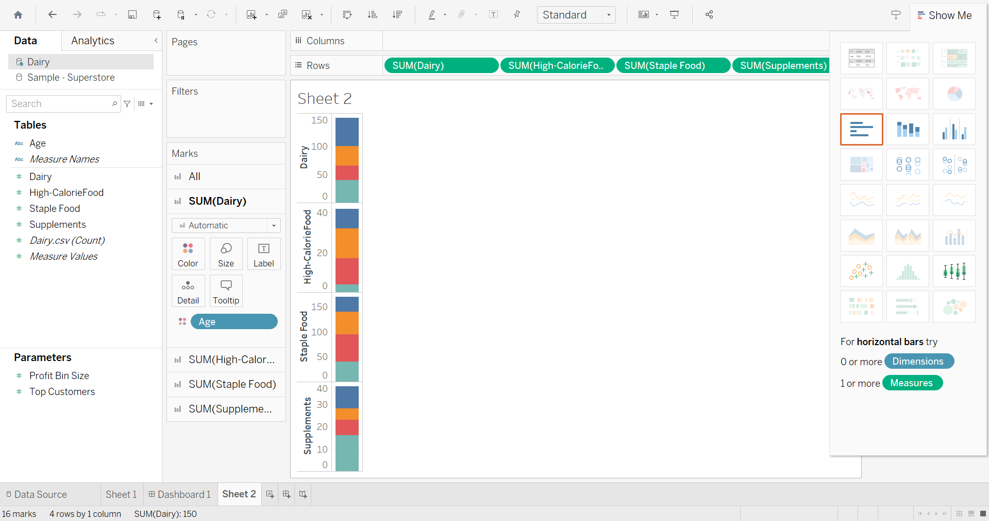

Line Plot

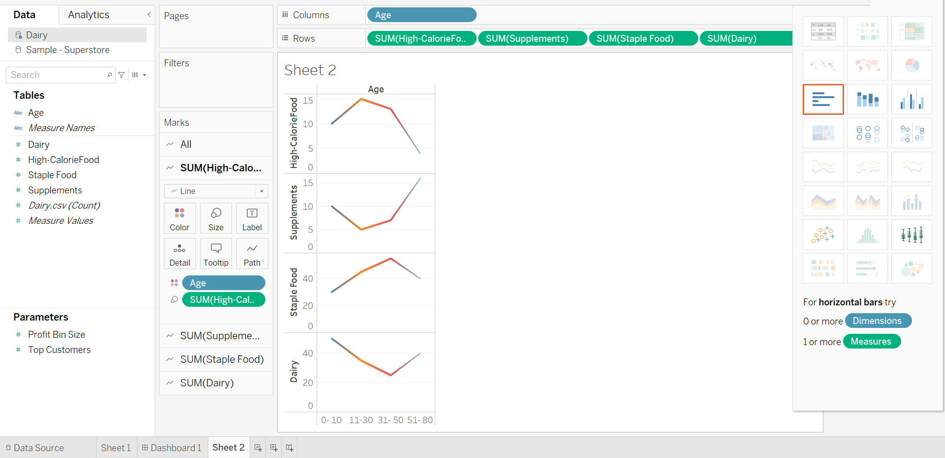

Scatter Plot

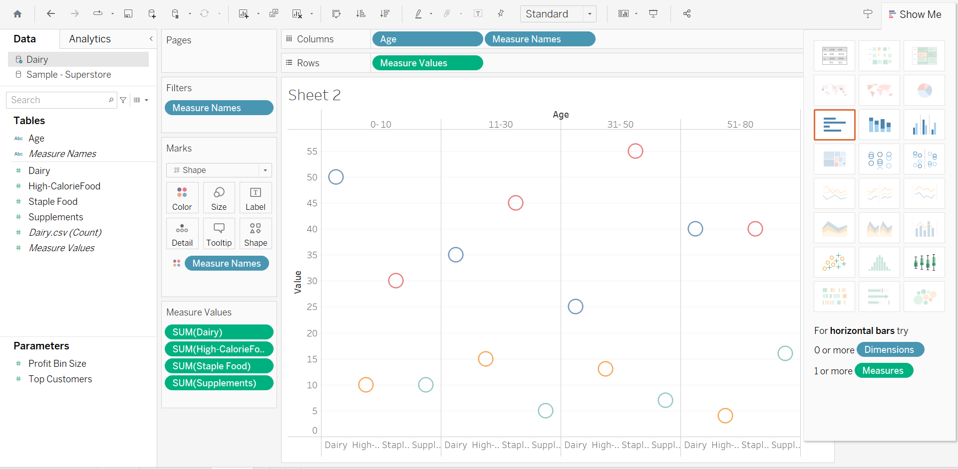

Mosaic Plot

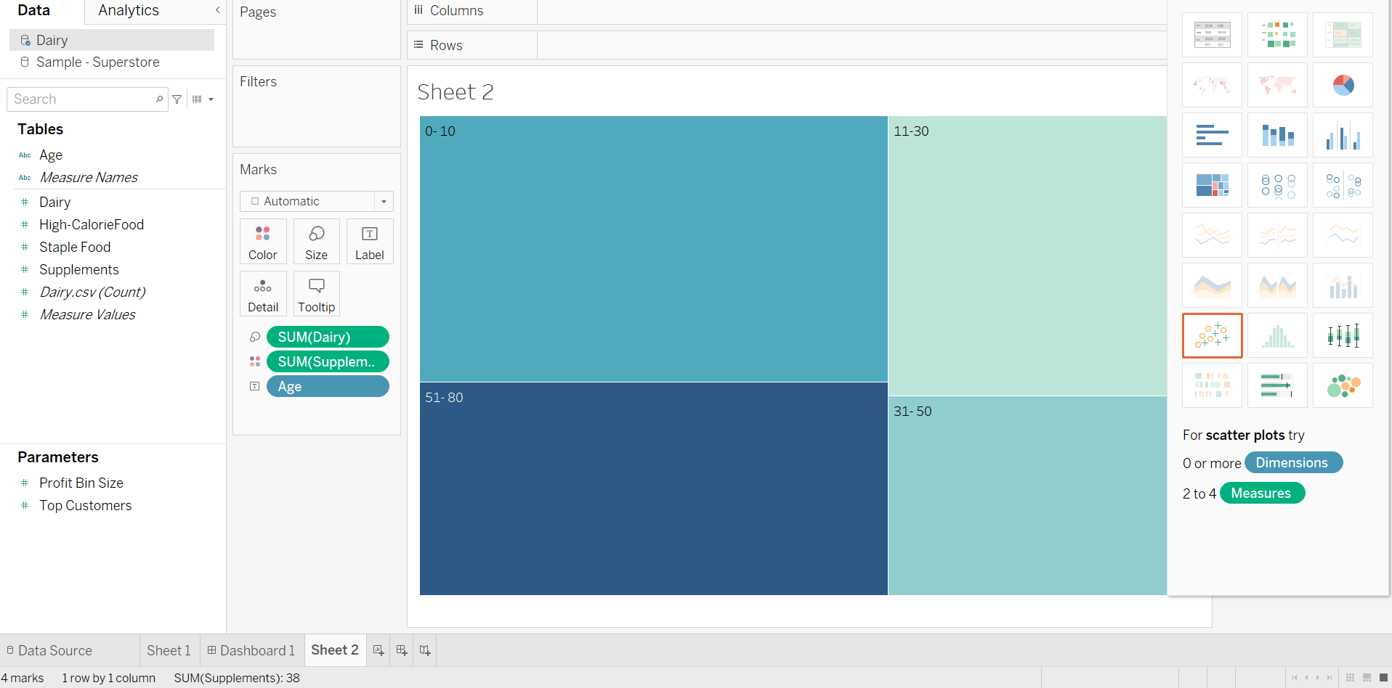

Histogram

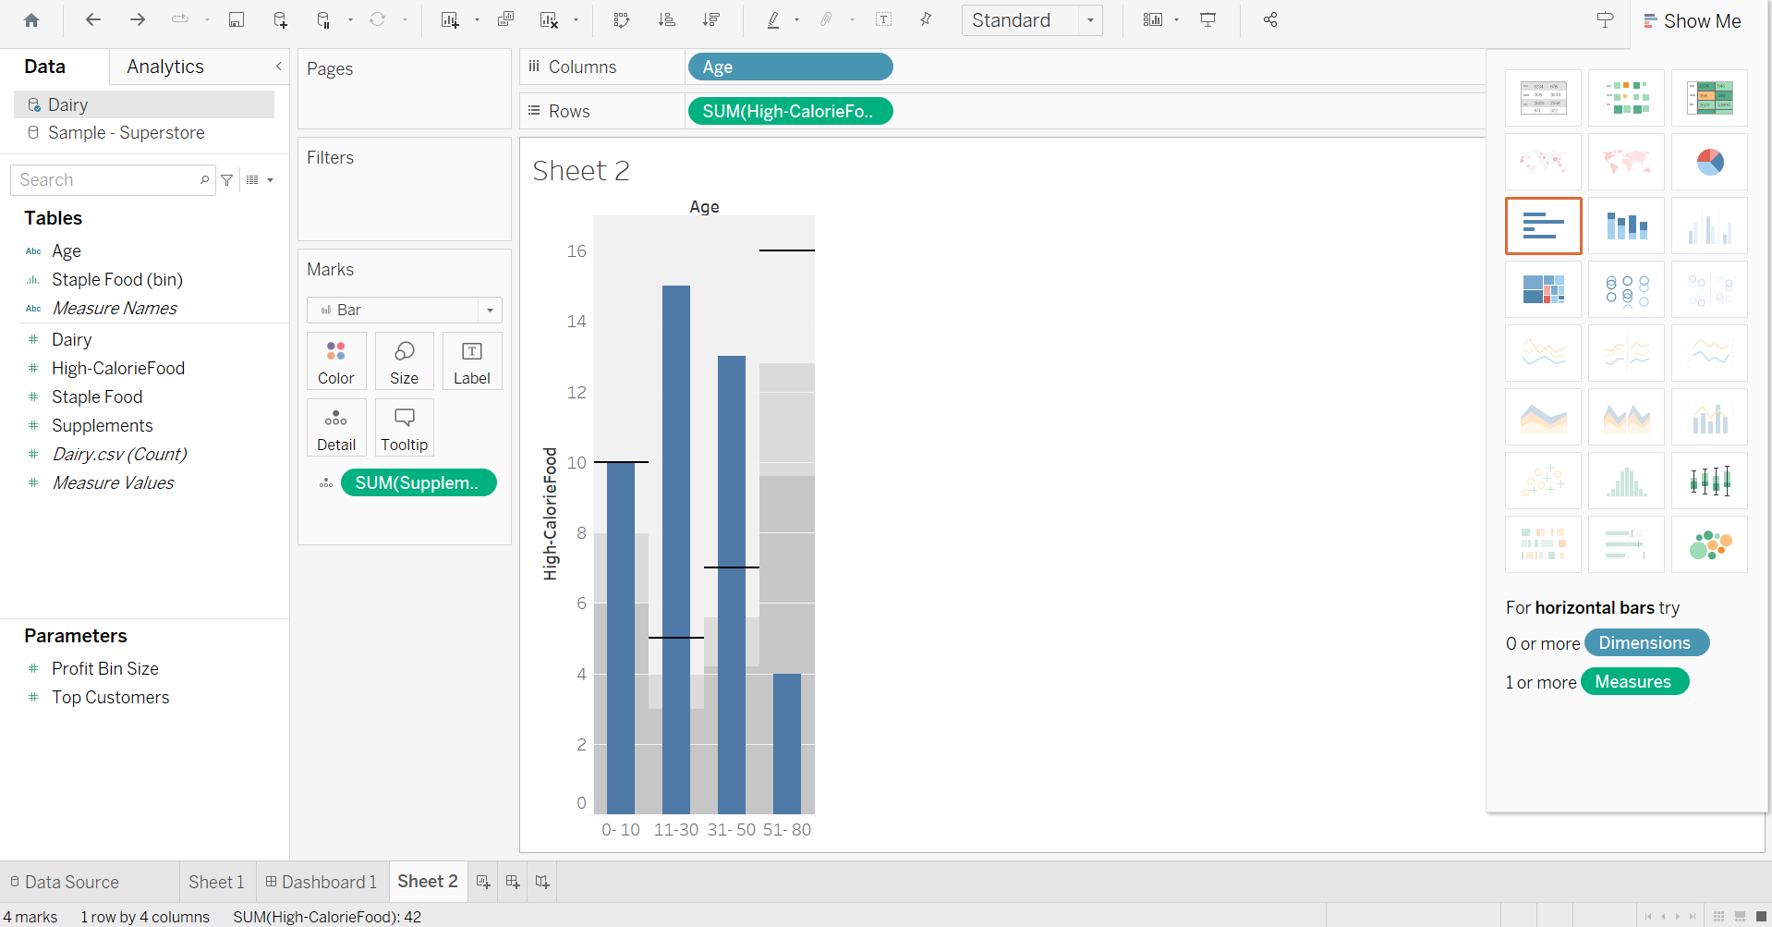

**Case study – 2**

Product Inventory Management - Stacked Bar Chart, Line Plot, Scatter Plot and Pie Plot, Histogram.

Line Plot

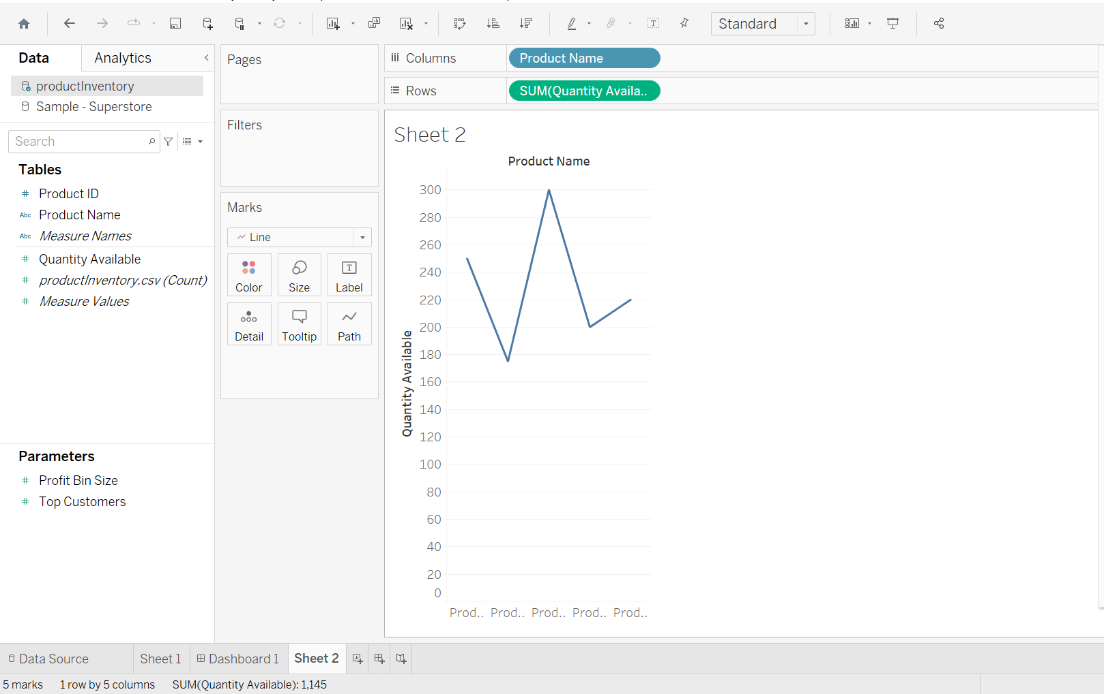

Stacked Bar

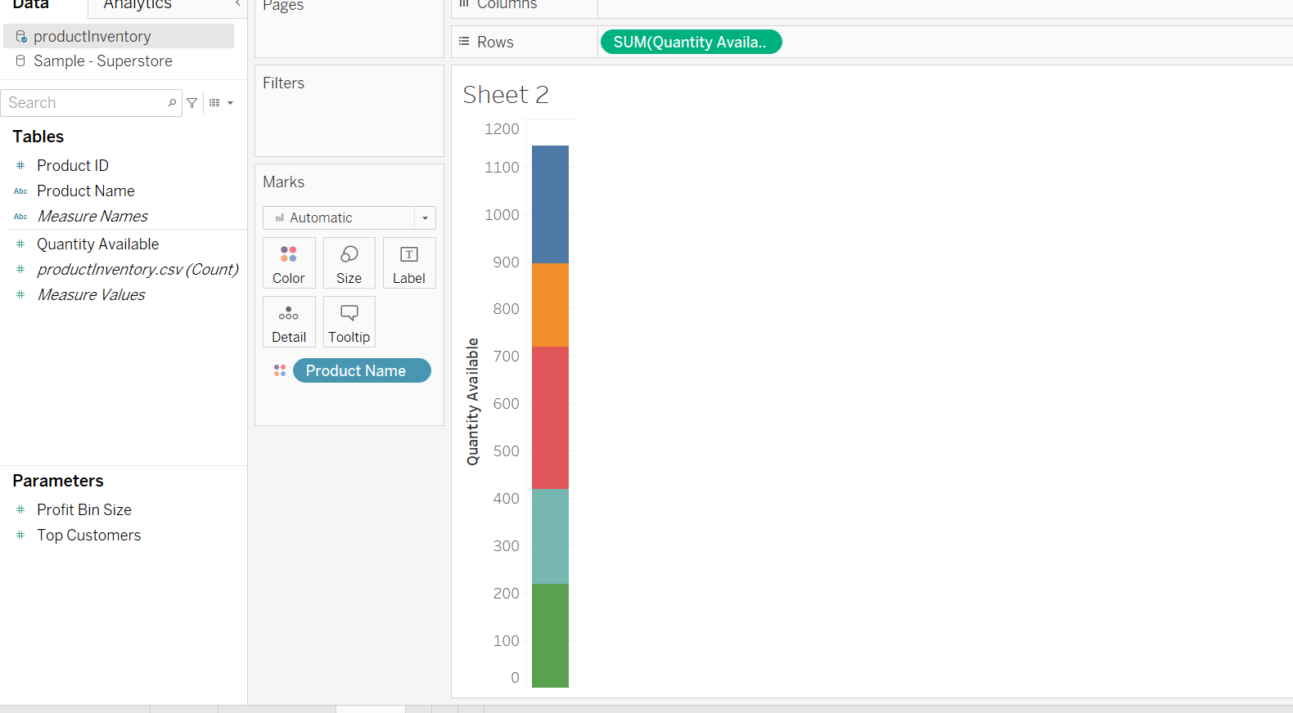

Scatter Plot

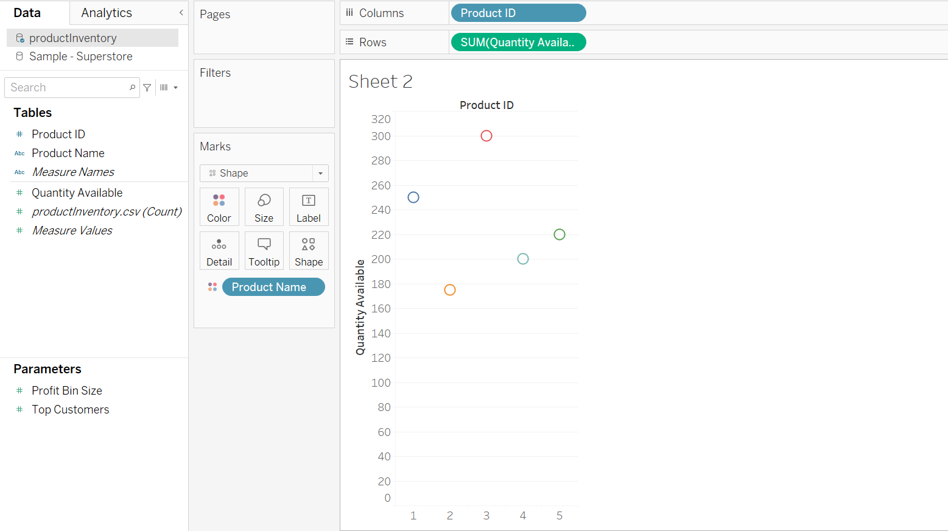

Histogram

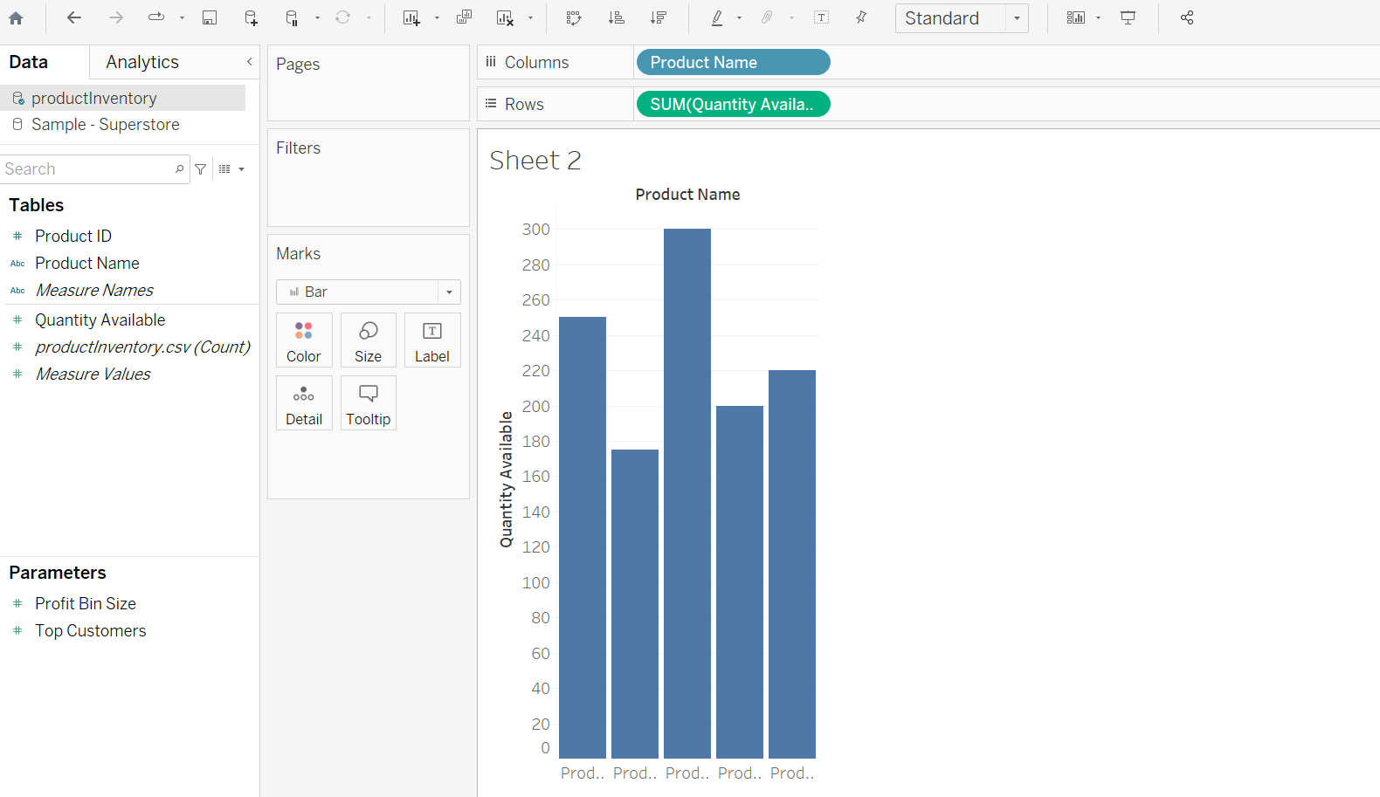

Pie Chart

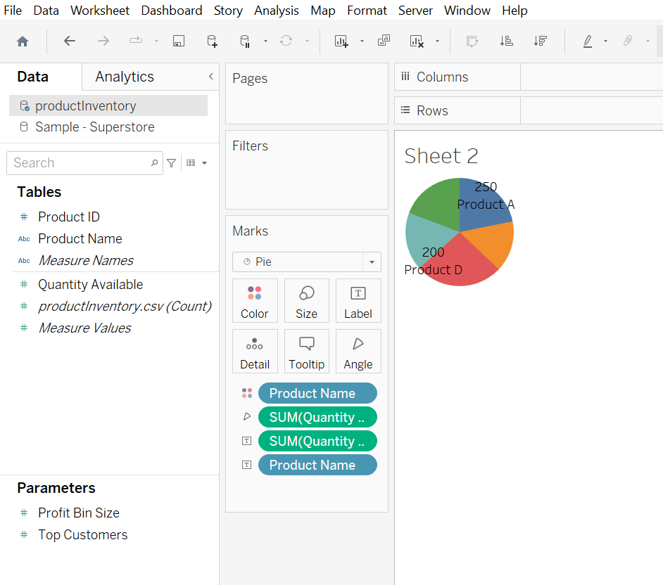

**Case study – 3**

Website Analytics - Stacked Bar Chart, Line Plot, Scatter Plot and Pie Plot, Histogram.

Line Plot

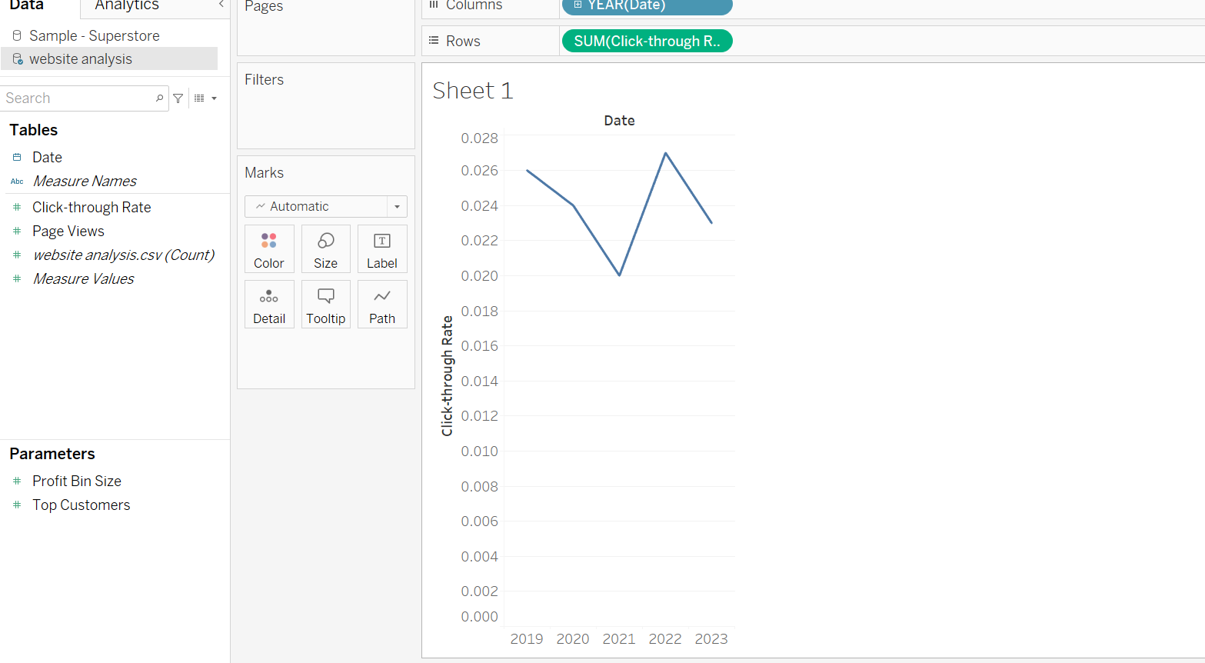

Stacked Bar Chart

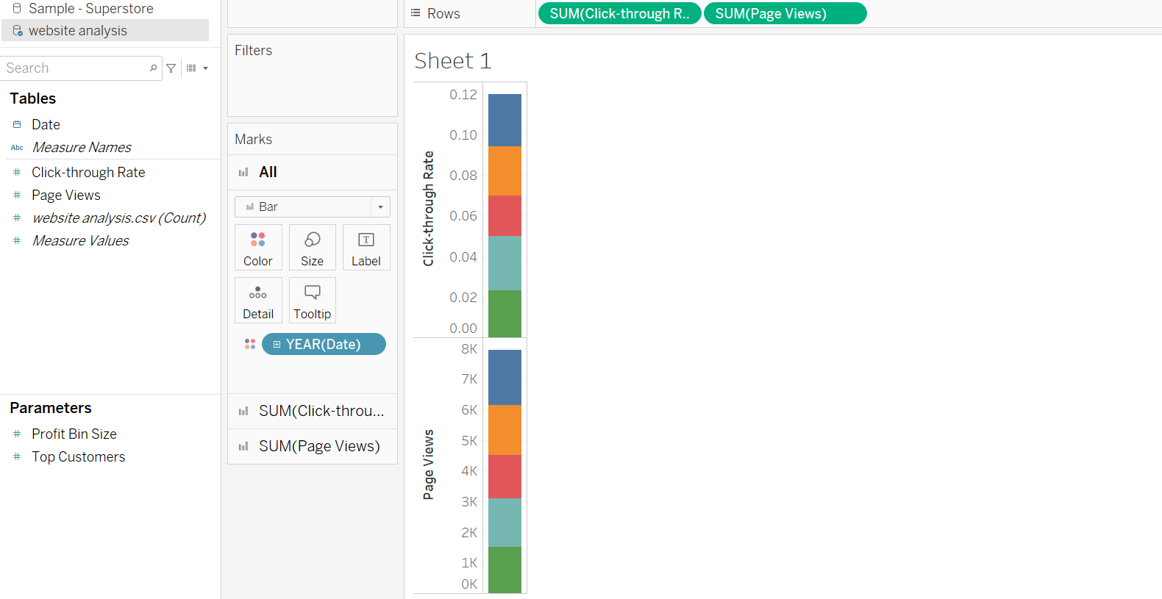

Scatter Plot

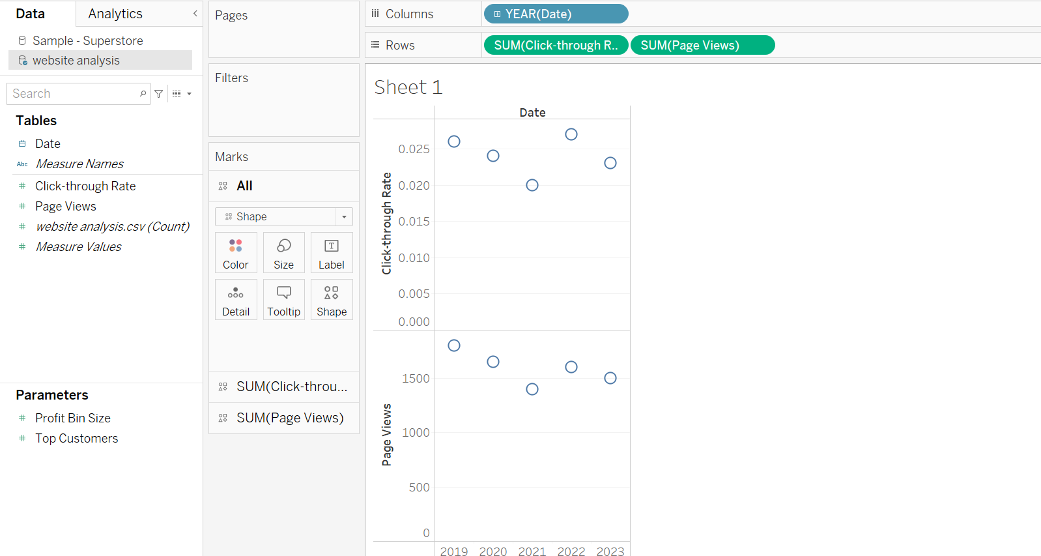

Pie Plot

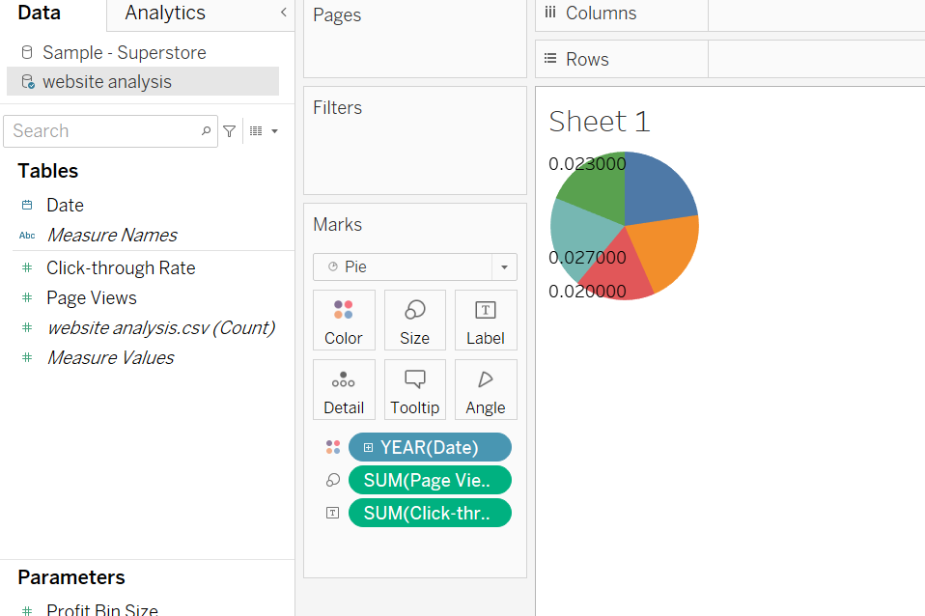

Histogram

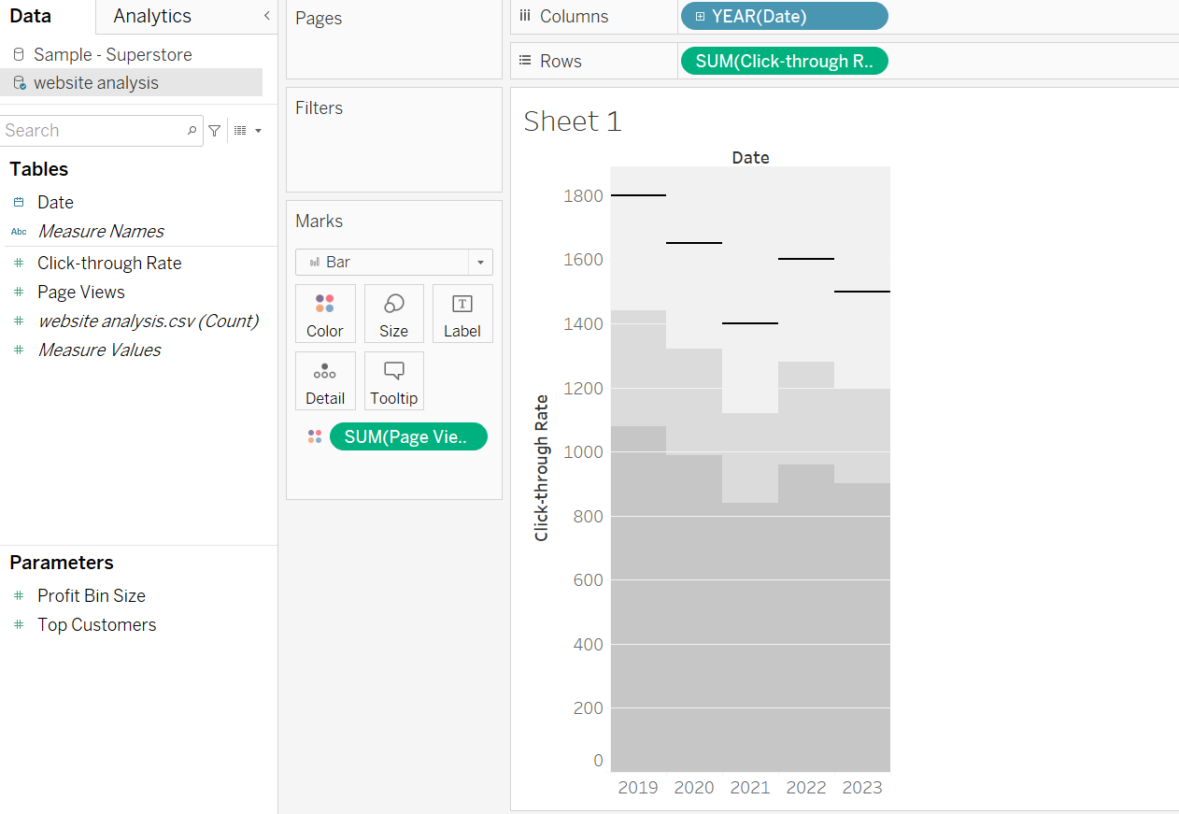

**Case study – 4**

Time Series Analysis – Scatter plot, Line Graph

Scatter Plot

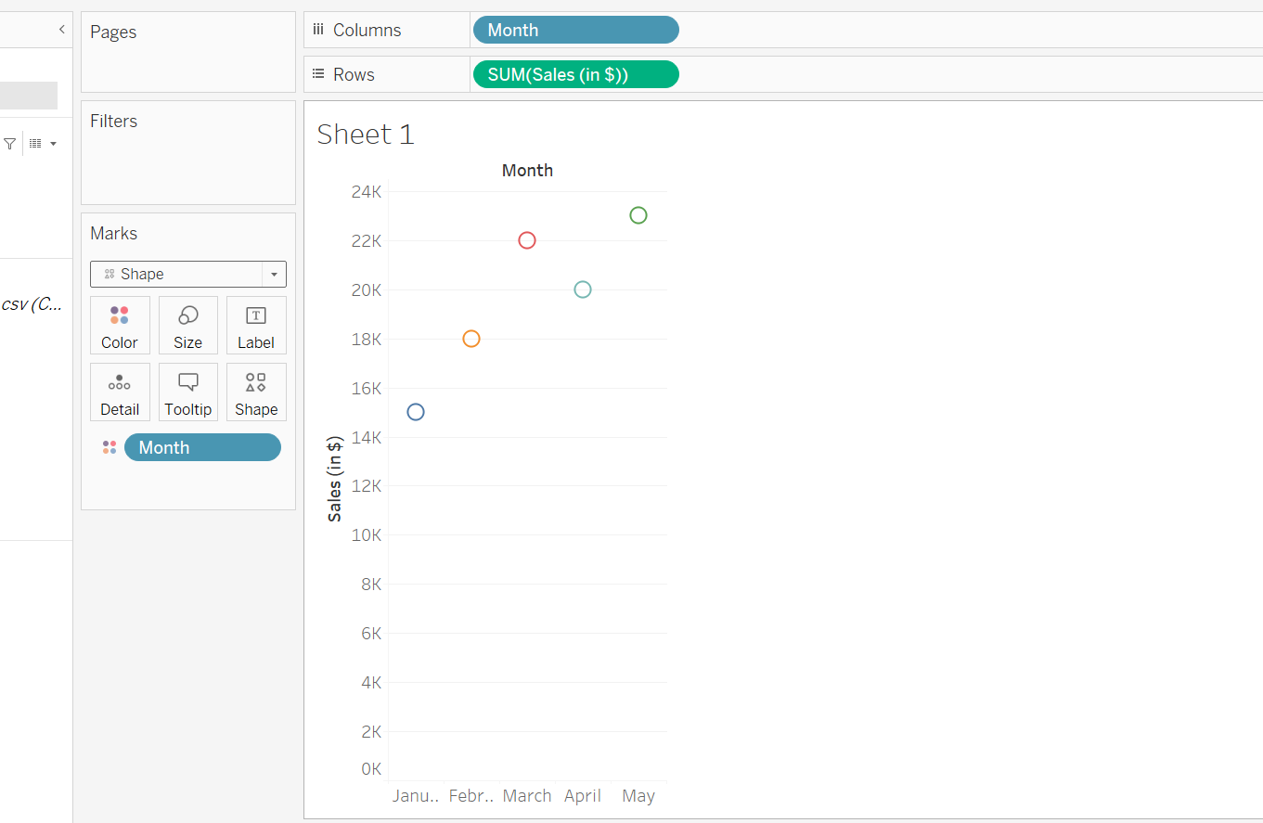

Line Graph

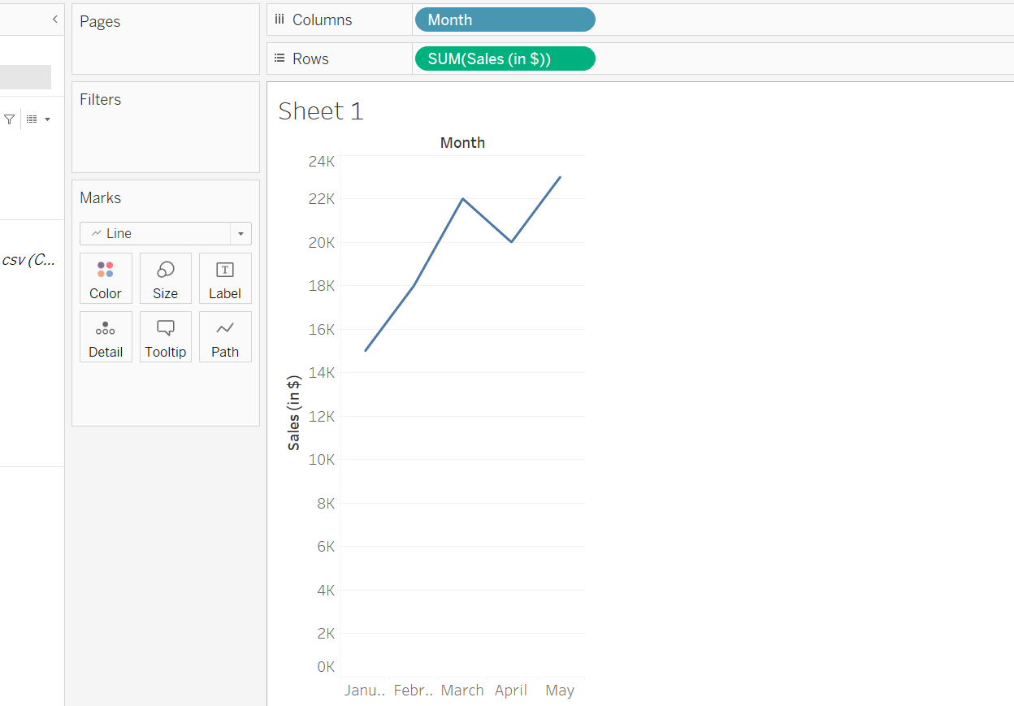

**Case study – 5**

Website Analytics - Stacked Bar Chart, Line Plot, Scatter Plot and Pie Plot, Histogram.

Line Plot



Stacked Bar Chart



Scatter Plot



Pie Plot



Histogram

